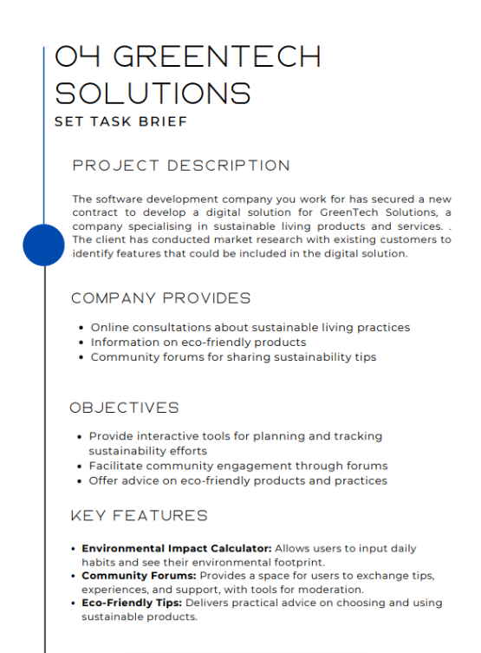

Proposal for GreenTech Solutions

1. Project Overview
GreenTech Solutions aims to enhance how users plan, track, and improve their sustainable living habits by introducing a modern digital platform. The goal is to make eco-friendly living easier, more accessible, and more engaging by offering interactive tools, personalised sustainability insights, and a supportive online community. The upgraded system will increase user motivation, promote environmentally conscious habits, and strengthen long-term engagement.
In addition, GreenTech Solutions plans to expand its services through a dedicated mobile app, offering users a unified and convenient space to learn about eco-friendly products, join community discussions, and receive tailored sustainability guidance.
The proposed digital solution will include:
- Environmental Impact Calculator
Allows users to input habits (energy use, transport, waste, diet) and receive personalised environmental footprint insights.
- Community Forums
A moderated discussion space where users share sustainability tips, advice, and experiences.
- Eco-Friendly Tips Hub
Provides practical guidance on sustainable living, eco-friendly products, and low-impact lifestyle choices.
These features directly support GreenTech’s mission of empowering people to live more sustainably.

2. Problems Identified
Problem 1 – Lack of Personalised Sustainability Support
Current advice offered by GreenTech is generalised and not tailored to individual lifestyles. Users cannot track their environmental progress, making long-term engagement difficult.
Problem 2 – Poor Community Engagement / No Centralised Discussion Space
Users currently lack a unified, well-structured platform to share sustainability tips, ask questions, or support each other. This limits community-driven motivation.
Problem 3 – Limited Access to Practical Eco-Friendly Advice
Information about sustainable products and practices is scattered across different sources. Users struggle to find reliable, up-to-date recommendations in one place.

3. Proposed Solutions
Solution to Problem 1 – Environmental Impact Calculator
An interactive tool that analyses user lifestyle data and generates personalised sustainability insights, progress trackers, and suggestions for improvement.
Solution to Problem 2 – Online Community Forums
A centralised moderated forum where users can ask questions, participate in themed discussions, share experiences, and support new members.
Solution to Problem 3 – Eco-Friendly Tips Hub
A curated library of tips, product suggestions, tutorials, and guidance on sustainable living, updated regularly and tailored to user interests.

4. Decomposition of Solutions
Environmental Impact Calculator
The Environmental Impact Calculator collects key lifestyle information from users, such as their energy use, transport choices, diet, and waste habits. Once the data is entered, the system works out the user’s environmental footprint automatically. It then gives simple, personalised suggestions to help reduce their impact.
The tool also shows progress charts and a history of habit‑tracking, so users can see how they’re improving over time. Users can update their inputs whenever their lifestyle changes, making it easy to compare progress weekly or monthly.

Community Forums
The Community Forums will be organised into clear topic categories so users can easily find discussions they’re interested in. Users will be able to create posts, reply to others, like useful content, and follow threads they want to keep up with.
Moderation tools such as reporting and admin controls will keep the forums safe and well-managed. Profiles can be customised with basic features and achievement badges. A built-in search tool will help users quickly find advice or discussions on specific sustainability topics.

Eco-Friendly Tips Hub
The Eco-Friendly Tips Hub will hold a collection of articles, practical tips, tutorials, and product information all in one place. Users can filter content by categories like energy, lifestyle, transport, and food to find what they need faster. The hub will also let users save or favourite useful tips. Trusted eco-friendly brands will be linked where relevant to help users make informed choices. The layout will be fully accessible and mobile-friendly to ensure smooth browsing on any device.

5. Client and User Needs
GreenTech Solutions wants a platform that makes sustainable living simple, engaging, and informative while strengthening community interactions.
Key User Groups
- Beginners: need simple guidance and step-by-step sustainability tips.
- Busy users: require quick, digestible advice and easy habit tracking.
- Eco-enthusiasts: want detailed data, advanced footprint insights, and community engagement.
- Disabled users: screen reader support, high contrast, scalable text, clear navigation.
- Tech-savvy users: expect real-time updates, interactive tools, and modern UI.

6. Mitigating Potential Risks
Environmental Impact Calculator
Incorrect inputs will be handled using basic validation prompts to help users fix mistakes. To avoid calculation errors, the system will undergo routine automated testing. Security will be kept tight using encryption, RBAC permissions, and secure APIs.
User Accounts
Forgotten passwords will be managed through a secure reset process with 2FA. To prevent account takeover, MFA and alerts for unusual login activity will be in place.
Community Forums
Inappropriate content will be controlled using moderation tools and content filters. Spam will be reduced with automated detection and admin reporting. Misinformation will be tackled through expert-verified posts and pinned guidance.
Eco-Friendly Tips Hub
Content will be checked regularly to prevent outdated information. Automated link-checking will be used to fix broken links, and encrypted backups will protect stored data.
Technical Reliability

Downtime will be reduced using cloud hosting and load balancing. Autoscaling and stress testing will help the system handle heavy traffic. Regular backups and recovery drills will ensure data can be restored if needed.

7. Security & Compliance Risks
Security Features
Encryption will be used to protect all user data, keeping information secure both while stored and while being transferred. Multi-Factor Authentication (MFA) will add an extra layer of login security.
Regular system audits will be carried out to check for vulnerabilities and ensure everything is functioning safely. Strict RBAC controls will make sure only authorised staff can access sensitive areas of the system.
All data handling will follow GDPR rules to keep user privacy protected. The platform will also meet WCAG accessibility standards to ensure all users, including those with disabilities, can use the system safely and effectively.
Legal Requirements
The Equality Act 2010 requires the platform to be accessible for disabled users, meaning features like clear navigation, screen-reader compatibility, and adjustable text sizes must be supported.
The Consumer Rights Act 2015 ensures that any product information or recommendations shown to users are accurate, transparent, and not misleading.
GDPR sets strict rules for how user data is collected, stored, and processed, making proper consent, secure handling, and user privacy essential.
Copyright and licensing laws must be followed when using third-party sustainability content, ensuring all articles, images, and resources are used legally and with permission.

8. System Requirements
Functional Requirements
The system will include secure user login and account management so individuals can create profiles, access personalised features, and manage their settings safely.
The Environmental Impact Calculator will allow users to input lifestyle data and receive accurate footprint results. An Eco-Friendly Tips Library will provide organised, easy-to-browse advice and resources on sustainable living.
Community Forums will enable users to post, reply, and report content to maintain a positive environment. The platform will also deliver personalised sustainability insights and progress tracking, helping users see how their habits improve over time.
Non-Functional Requirements
The platform must maintain 99.9% uptime to ensure users can access tools and resources reliably. Strong security measures will protect accounts and sensitive data.
The system should perform quickly even during heavy usage, providing fast loading and smooth interactions. A scalable infrastructure will allow the platform to grow as more users join. Full WCAG accessibility compliance will ensure the platform is usable for all, including people with disabilities.

9. Key Performance Indicators (KPIs)
- Calculator Accuracy: The Environmental Impact Calculator should reach at least 90% verified accuracy within the first four months, ensuring users can trust the footprint results and recommendations it provides.
- Engagement Rate: The platform aims to increase the number of active users by 30% within six months, showing that more people are regularly interacting with its features.
- Forum Participation: Community activity should grow by around 20%, measured through increases in posts, replies, and ongoing discussions within the forums.
- Page Load Time: All main pages should load in under 2.5 seconds to keep the user experience smooth and prevent frustration or drop‑offs.
- System Uptime: The system must remain available 99.9% of the time, ensuring users can access tools, forums, and resources with minimal downtime.
- User Retention: User retention should increase by 15% within six months, showing that people find value in the platform and return consistently.

10. User Acceptance Criteria (UAC)
Environmental Impact Calculator
The calculator must produce accurate and reliable results based on user inputs. Graphs and progress indicators should be clear and easy to understand so users can track their improvements over time. Lifestyle inputs must be fully editable, allowing users to update their habits whenever needed.
Community Forums
Users should be able to post and reply smoothly without errors or delays. The search function must return accurate and relevant results when looking for topics or advice. Reporting and moderation features need to work correctly to keep discussions safe and well-managed.
Eco-Friendly Tips Hub
The Tips Hub should load quickly on all devices to provide a smooth browsing experience. Category filters must work properly, helping users find the content they need. Saving or favouriting tips should function reliably so users can return to their chosen articles easily.
Navigation
All features should be accessible within three taps or fewer to keep the platform simple to use. Page layouts must remain consistent across the site, so users always know what to expect. The platform must also work well with screen readers to support accessibility for all users.

